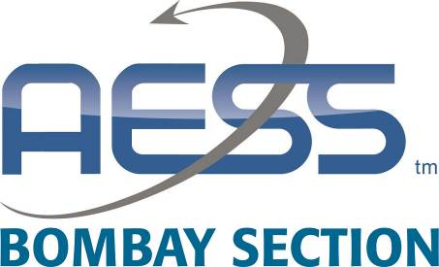

IEEE Bombay Section Aerospace and Electronics Society Chapter

AAKAAR
Shaping the Idea

AAKAAR is a competetion to select ideas which could be conceptualised into product by providing a grant-in-aid to facilitate completion of prototype/product. This competition is open to IEEE Members of any grade including student members.

The idea should be in the domain of Aerospace / Electronics.

Winners of AAKAAR will get a direct entry to Sardar Patel Technology Business Incubator (SP-TBI) NIDHI PRAYAS Final Pitch Round for a grant-in-aid funding between 5 Lakh to 10 Lakh INR.

Each winning idea will also be reimbursed Rs 2500 towards expenses for the final pitch.

Last date for Submission of Application form : 03 January 2022
Last date of submission of Query Responses : 07 January 2022
Announcement of Result: 13 January 2022

(Final Pitch Round of SP-TBI is proposed to be between 20 – 31 January 2022.)

Individual Innovator Application form

- Title of the proposed project:

- Innovator Details:
  - Personal Details
    - Name of the Innovator :
    - Completed Age in Years :
    - Email ID:
    - Mobile Number :
    - IEEE Membership Number :
    - Whether member of IEEE AESS :
    - Educational Qualification:
    - Address :

  - Professional Details
    - Profession of the Innovator:
    - Name & Address of the Institution/Organization (applicable in case of Innovator in Employment / Students with any R& D organisation / Academic Institution):-
    - Have you started your own venture (start up) ? Yes / No
If yes, please mention the following
Name of your start up
Your Role in start up(eg. CEO, COO, Product Head etc)
Date of Incorporation

  - Team Member Details if Any

- Brief description of the idea highlighting innovative element.

- (a) Status of work already carried out (if any) such as. Please tick ✓as applicable.
- Idea level
- College Project
- Lab level – Proof of Concept
- Paper Presentation
- Working Prototype ready

(b) Working principle behind the idea, in brief

(c) Final outcome/deliverable of the project

(d) Who would be the beneficiary of this innovation and why?
(Please use a separate sheet, if necessary)

(e) Project period in months: ________________________
(Not more than 12-14 months)

- Approximate Proposed costs and time frame

Sr.No | Items | Project Cost  Own Share, if any | PRAYAS support sought
1. | Outsourcing Charges for R&D/Design  Engg/Consultancy/Testing/Expert cost
2. | Raw material/ Consumables/Spares
3. | Fabrication /Synthesis charges of working model or process
4. | Business Travel and Event participation Fees (Ceiling 10% of approved project cost)
5. | Patent filing Cost – (PCT- Ceiling 10% of approved project cost)
6. | Contingency - (Ceiling 10% of approved project cost)

- Activity details/work plan

Sr.No | Activities | Monitorable Milestones | Duration (months)

- Have you received financial support / award for work done until now from another sources? (if so, please furnish details)

- Essential Criteria

Applicant Confirms that he/she has not received any NIDHI-PRAYAS or similar support previously for the same innovative concept as proposed in this form. NIDHI-PRAYAS can be used only once. | YES

- Declaration:I declare that all the statements made in this application are true, complete and correct to the best of my knowledge and belief. If any information is found false or incorrect, my application will standcancelled and all my claims will be forfeited. I also hereby reconfirm that I have not received anyfinancial assistance for the work indicated in the present proposal from any other agency.

If selected a winner, I understand that the detailed application form for (SP-TBI) NIDHI PRAYAS will have to be submitted by me by 16 January 2022 to be considered as a candidate for Final Pitch Round. The form will be provided to prospective idea candidates at the time of selection.

Name of the applicant
Place:
Date:

Application form to be submitted via email to aakaar@ieeebombay.org

